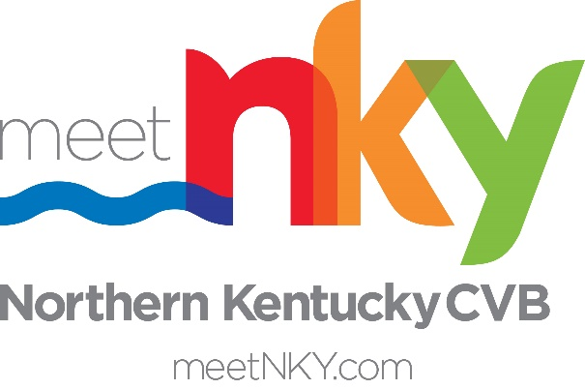

meetNKY Sponsorship Program
Application
The meetNKY Sponsorship Program provides financial support for events and special projects that demonstrate an ability to enhance the local tourism industry of Boone, Campbell and Kenton County.
The primary purposes of the fund are:
- To stimulate the creation of new or expansion of existing events that demonstrate an ability to enhance the economic benefit of the three counties.
- To support events/initiatives that enhance the quality of place for Boone, Campbell and Kenton residents and visitors.
Applications are reviewed on an on-going basis.
APPLICATION SUBMISSION INSTRUCTIONS
- Before you begin your application, please prepare the following required documents:
  - Sponsorship Kit
  - Event Budget (Include all known or projected expenses and revenues)
  - Supporting Materials: marketing materials, media coverage, photographs/videos
- Applications must be submitted at least 90 days prior to the event.
- Completed Applications and back up documentation can be submitted to hello@meetNKY.com with event name/project name in subject line.

Organization Information
Name of Applying Organization:
Please indicate your organization's non-profit designation or other:
Organization's Website:
Please describe your organization's mission:

Executive of Organization
﻿Please complete the following information for the President / Executive Director of the applying organization
Name (Executive of Organization)
First Name
Last Name
Email
Phone
Lead Event/Project Contact
Please provide information for the person that meetNKY should communicate with regarding the event and sponsorship.
Contact Name:
Email:
Phone:
Event Location – if proposed sponsorship is event based
Name of Event:
Event Start Date:
Event End Date:
Use same date as start date if event is a one-day event.

Please provide a brief description of the event, including its history.

Please describe the audience of this event.

What is the estimated attendance for the event?

What percentage of attendees come from outside Boone, Campbell and Kenton County?

Has this event been held before?

Please describe how you plan to market the event.

How much do you plan to spend on marketing the event? Please list all anticipated marketing expenses.

Project Location – if proposed sponsorship is project based
Please provide venue name(s) and address(s) if applicable, or description of location if no specific venue is applicable.
Please provide a brief description of the project, including its history.

Please describe the audience of this project and its proposed impact on tourism in Northern Kentucky.

Financials
Please provide the following financial information about your event/project.
What are the total projected expenses:

What is the requested sponsorship request:

Please list all available sponsorship benefits (including the inclusion of meetNKY’s logo/website and the Team Kentucky logo):

Please list other confirmed sponsors:

meetNKY Tourism Master Plan Alignment
Please describe how the event is aligned with any of the 13 strategic initiatives of NKY Tourism Master Plan or the Appendix A Continuing Focus Projects. A copy of the plan can be reviewed HERE.
Examples:
- Ability of event to attract out-of-town attendees for day trips and overnight visits
- Hosting event in needs period - off peak seasonally and midweek
- Ability to disburse visitors outside the riverfront in NKY
- Providing employment opportunities for NKY residents
- Strategic investments in tourism impact projects

How is your event/project aligned with the NKY Tourism Master Plan:

