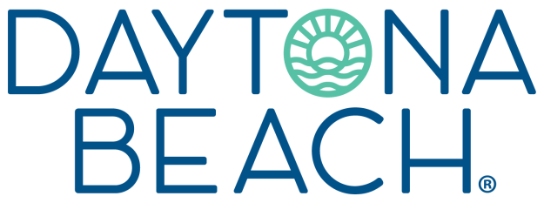
Just for Kids!
Make Time for These Attractions

School's out for summer! It's time for lazy beach days, electric summer nights and nothing but good vibes.

The Daytona Beach area offers something for everyone, especially kids and kids at heart. From 23 miles of iconic beaches and water activities to adventures on the mainland at the Charles and Linda Williams Children's Museum at the Smithsonian-affiliated Museum of Arts and Sciences and "The World Center of Racing" Daytona International Speedway, your Daytona Beach vacation promises to provide plenty of sun, fun and precious, lifelong memories.

10 KID-FRIENDLY ACTIVITIES

WHAT'S NEW
VR Experience at Daytona Aquarium & Rainforest Adventure
Daytona Aquarium & Rainforest Adventure is offering a new virtual reality experience with five options to choose from: A Mermaid's Quest — Save Our Oceans, Swimming With Humpbacks — Dive With Giants, Thrill Coaster — Soar Above the City, and Shark Dive — Get Closer Than Ever. MORE>

UPCOMING EVENTS

** Daytona Tortugas at The Jack
------------------------------------------------------------
Daytona Beach's very own boys of summer are back at bat. Through September, you can experience the fun and fanfare of MiLB games when the Daytona Tortugas, a Cincinnati Reds affiliate, take on the competition. Click on the link for the game schedule and ticket info.
MORE>

** Plan Your Daytona Beach Getaway
------------------------------------------------------------
Take advantage of the sizzling summer deals being offered by Daytona Beach area hotels and resorts. Check out these offers and start planning your next trip to Daytona Beach today!
Find Your Deal>

To access destination images, visit the Daytona Beach Media Gallery and register.

