2025

Handbook
Show Me How

Getting Started:
- It’s highly recommended that you keep a dedicated Paycom folder (digital or physical) for all cheat sheets, weekly emails, and helpful resources.
- Please attempt to resolve any issues yourself using the provided documentation before reaching out for help.
- If you're still having trouble, contact Destination Services for assistance — they also refer to the same documents you’ve been given.
- Until Paycom becomes second nature, refer to:
  - Emails from Destination Services
  - Your Paycom handbook
  - Weekly Reminder Emails (to approve your 1st & 2nd week of time)

Paycom Access:
- Paycom can be accessed via mobile app (this is required to clock in) or Paycom website.

Quick Access to Training Videos:
- Clocking-In: Watch Video
- Punch Change Request: Watch Video
- Editing a Punch: Watch Video
- Approve Timecard: Watch Video

Accessing Other Show Me How Videos:
- Location: on Paycom Under Learning > My Learning > Paycom University, then filter by Topics of Interest.
- These videos are for reference, not required training.

Need Help/Who to Contact:
- Password/Technical Issues: Contact HR at (817) 410-3176.
- Pay Issues: Email the Destination Services Department or call (817) 410-3538 or (817) 410-3191.
- For unresolved issues, contact Pat Burkholder at (817) 410-3116.

Clocking In – Key Steps:
Rule of Thumb: Do not clock in more than 5 minutes prior to your scheduled shift.
- Option 1: Quick Punch (Preferred Method)
  - When onsite for your assignment, use the blue dot 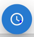 from the home screenon your Paycom App.
  - Quick Punch is the preferred method, as it directly takes you to the "IN DAY" option.
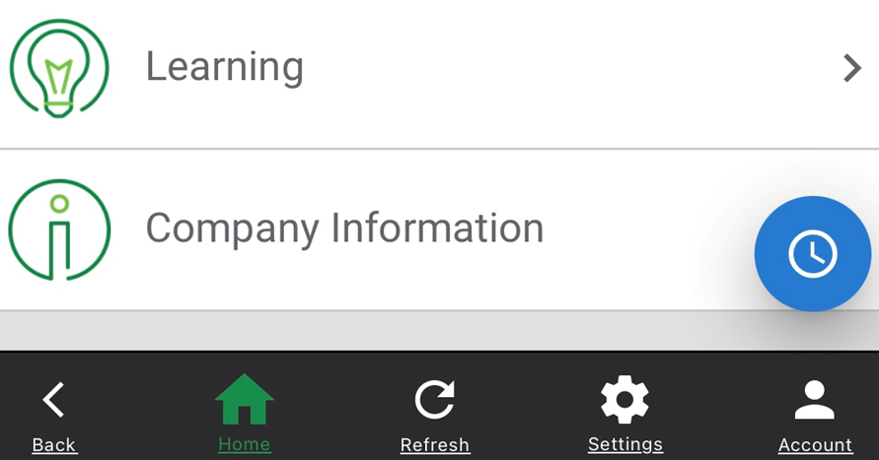
- Option 2: Web Time Clock
  - Another method to clock in.
  - You can also check your status (clocked IN or OUT), but it may be easier to miss adding a comment code, so Quick Punch is recommended.
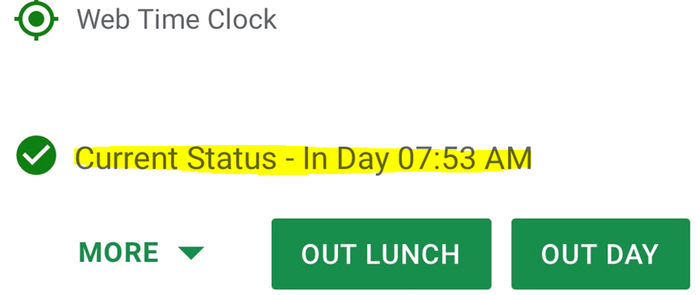

Alternate Functions (Allocation):

YOU REQUIRED TO SELECT ONE OF THE FOLLOWING
- RA 405 (Default Code): (Less Common)
  - This is the default Alternate Function chosen if no other code is selected. It’s used for non-convention work.
  - Examples:
    - Destination Grapevine Class
    - Burgundy Brigade Meetings
  - You will be instructed when to use this code.

Alternate Function Choices:
- RA Convention - 406: (Common)
  - This code should be used for convention-related work, as shown in the example below.
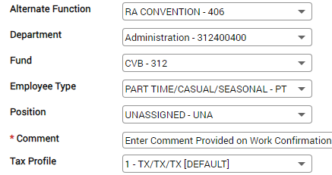
- CVB Festivals - 408: (Used Frequently During CCOT)
  - When working Festivals/CCOT, you must select “PART TIME/CASUAL/SEASONAL-PT” from the dropdown.
  - All other dropdowns will only allow one option to choose, which simplifies the rest of the selection process.
- RA Hanging Signs - 410: (Less Common)
  - Use this code only when hanging signs, with the same options selected as RA Convention - 406, Comment will be provided by Betty or Lauren.

Key Takeaways:
- RA 405 is the default for non-convention work unless otherwise specified (less common)
- RA Convention - 406 is used for convention work. (most common)
- CVB Festivals - 408 is used for Festivals/CCOT (used frequently during CCOT)
- RA Hanging Signs - 410 applies to hanging signs positions (less common)

Comment Codes:
- Comment Code Entry:
  - Always enter your Comment Code before selecting "IN DAY."
  - Quick Punch is the preferred method for clocking in since it automatically puts each step-in order, and the last option will be selecting "IN DAY."
- Standard Comment Code Format:
  - Capital Letter (default) followed by small letters. This prevents you from having to manually capitalize the code.
  - For Festivals/CCOT, you may be asked to include the area where you worked (Ex. Ccot lobby, Gf info)
  - You should not deviate, add dashes or other characters. Simply type the provided code exactly as instructed.
- Where to Find Your Comment Code?:
  - The comment code (or the abbreviated convention name) can usually be found on:
    - Your work confirmation and/or schedule.
    - Sometimes, it may be in the email confirmation for your assignment.
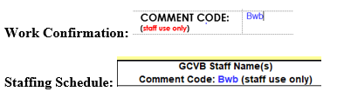
- Purpose of Comment Codes:
  - Comment codes help track groups/events worked, which is important for:
    - Accurate billing to clients.
    - Tracking the hours worked by the Burgundy Brigade for future planning and budgeting.

Clocking Out and Approving Time – Key Points

Clocking Out:
- Select "OUT DAY" when clocking out.
- Clock Out Expectations:
  - You are expected to clock out at the conclusion of your shift or if the onsite contact releases you earlier than your scheduled end time.
  - If your actual clock-in/clock-out times differ from the scheduled times, you must add a comment explaining the discrepancy before clocking out in the comment section (Ex. Jane released early, Jane asked me to stay 30 min extra)

Approving Your Time – Pay Period

Policy Reminder:
- You must approve your time after completing each shift.
- If your time is incorrect, do not approve it. Take the necessary steps to fix your time.
- Only YOU can approve your time—no one else can do it for you. If you're unable to approve your time, you will receive an email with a screenshot of your Paycom entry. Reply to authorize approval if everything looks correct. If we enter your time for you, we will also need your authorization to approve it.
- Your Time for the ENTIRE week must be approved by Monday morning each week.
- If you have a punch request submitted over the weekend we will have to approve the correction on our end before you can. This typically happens after 9 a.m. on Mondays.
- You cannot approve your time until a punch request is approved so be sure to check back for approval.

Pay Period Overview:
- The pay period runs Bi-Weekly from Sunday to Saturday.
- You must approve the entire two-week period if you’ve worked even one day during this time. If you haven’t worked during the two-week period, you don’t need to approve anything for the pay period.

Approving the First Week:
- Approve your time as soon as you clock out for the day (if all is correct)
- If any days haven’t been approved, go to the first week’s dates (Sun. – Sat.) and select Approve by Date to close out the week. The first week will turn yellow once approved.

Approving the Second Week:
- At the end of the two-week period, approve all days, even if you’ve worked just one day.
- Select Approve Pay Period to close out the second week. This will turn yellow.
- If you’re not working on Saturday, make sure Saturday is checked as well (sometimes this is unchecked)

How to Approve Your Time:
- Go to Time Management:
  - Navigate to Web Time Sheet Read Only to review your hours.
- Verify Your Details:
  - Make sure your time, allocation code, and comment code are correct.
  - You can verify your allocation by:
    - Selecting the drop-down arrow next to the date you want to review.
- Approve Your Time:
  - If everything looks good, select Approve by Date for the days you worked or Entire Pay Period if you are not scheduled to work for the remainder of the pay period.
Color Indications:
Yellow Dates: These are the dates you have approved, but we have not yet approved on our end.
Green Dates: These are the dates that both you and DS team have approved.
White Dates: These are the dates you have not yet approved, and we will not approve them on our end until you approve them (Yellow).

Important Notes:
- Automatic Checkmarks:
  - If you haven’t worked on past days, checkmarks will automatically appear. Leave them checked as you approve.
  - If you’re approving time the day after you worked, a checkmark will appear for the current day. Uncheck this if you're still working on that day before hitting Approve by Date.
- Accidentally Selecting "Approve Pay Period":
  - If you accidentally select Approve Pay Period while still scheduled to work additional days in the pay period, unapprove it immediately, or you won’t be able to clock in. For help, see How to Unapprove Your Time.

REQUEST PUNCH EDIT:
- Navigate to: Time Management > Web Time Sheet (Read-Only).
- Fix the time: Click the drop-down next to the hours on the date you need to correct.
- Edit Time:
  - Click on the blue "IN" or red "OUT" to bring up the REQUEST PUNCH EDIT screen.
  - Date: Use the calendar to verify and select the correct date.
  - IN/OUT: Select what you're adding using the drop-down.
  - Punch Details/Punch Time: Enter the correct time (verify AM/PM).
  - Allocation: Select the appropriate allocation (in blue).
  - Reason for Punch Change Request:
  - Additional Comments: Always enter the provided comment code from your work confirmation first then enter reason for request (ex. Forgot to clock out)
  - Click Add Request to submit the request for review. You won't see changes until we approve request.
  - Request will appear as this PENDING >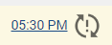
  - Request will appear as this once APPROVED by us>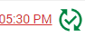
After we approve you can then APPROVE your time.

Missing Punch:
- Missing Punch Indicator: "?? / ??" (blue indicates IN / red indicates OUT).
- Fix Missing Punch: Click the "??" and follow the same steps as the "Requesting Punch Edit"

Forgot Your Phone at Home?:
- Fix: Go to Time Management > Web Time Sheet (Read-Only) > Tap Add Entry 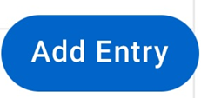
- Follow Steps: Select REQUEST NEW PUNCH and complete the process as described above.
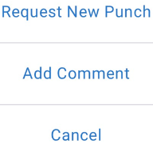

Forgot Your Comment Code or Shift Information:
- Fix: Same as "Forgot Your Phone" process.
- Steps:
  - Enter Dates: Use the calendar to specify the "From" and "To" dates.
  - Add Comment: enter the provided comment code from your work confirmation first then enter reason for request (ex. Jane released early at 12:15pm).
  - Click Add Comment.
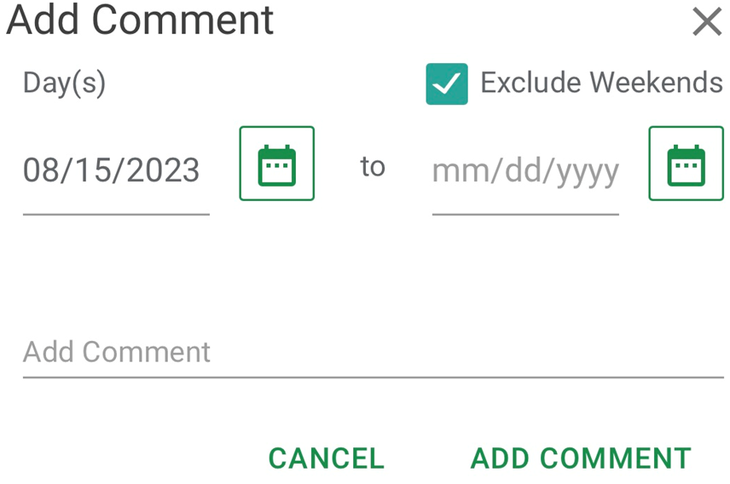

Editing Your Comment Code:
- Fix: Go to Time Management > Web Time Sheet (Read-Only), tap the drop-down arrow next to the date. >
- Edit Comment:
  - Scroll to the grey comment box, click to edit, update your comment, and click Update Comments.
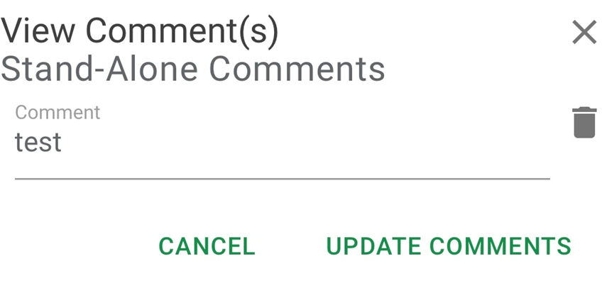

Revoking Approvals

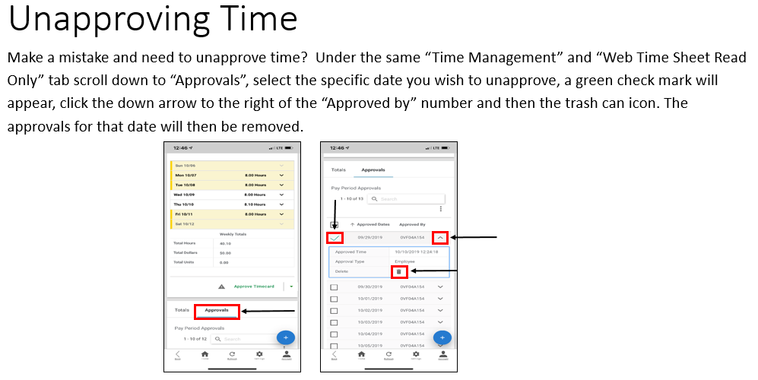
Confirmation:
  - Once you select "Revoke Approvals," the approvals for the selected dates will be removed, and you can now make changes or updates to your timesheet.
  - NOTE: if your time sheet is blue/green you will not be able to delete your approval since we have approved it already.

Need to Switch Pay Periods?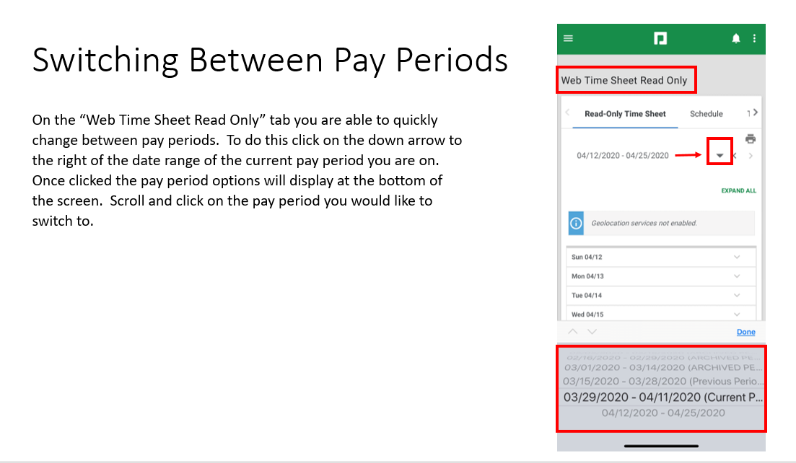

Comment Codes (Cheat Sheet)
Be sure to use the correct comment code when logging hours. These codes help track where and how time is spent.

General Codes:
- Admin + Area – Use when working in departments without a specific code.
Example: Admin Accounting, Admin Marketing
- Bb + Event/Training – Use for training, meetings, orientations, or DG-related work.
Example: Bb dg, Bb meeting, Bb orientation
- Brochure Delivery – Use if assigned to deliver brochures.
- Conv Center – Rare; only use if assigned to work at the Convention Center.
- Depot – Use when working regular train runs (not CCOT).
- Dest Services – Use when assisting Destination Services with office work or projects.

Special Events/Projects:
- Ccot + Area – Use for Christmas Capital of Texas events.
Examples: Ccot decorate, Ccot tkt, Ccot greeter, Ccot lobby, Ccot helpers, Ccot phone bank, Ccot tkt prep
- Gf + Area – Use for GrapeFest assignments.
Examples: Gf lobby, Gf Sales, Gf info, Gf phone bank
- Msf + Area – Use for Main Street Fest work.
Examples: Msf lobby, Msf Sales, Msf info, Msf phone bank
- Hf – Use for Heritage Foundation events.
Examples: First Friday, Candlelight Tour of Homes, Nash Farm events
- Gallery – Use when working a gallery event or reception.
- Leisure Kiosk – Use when staffing the hotel lobby kiosk at the Gaylord. If working a group kiosk in the front lobby, use the group-specific code listed on your staffing sheet.
- Palace – Use for all work at the Palace Theatre, including CCOT activities.
- Switchboard – Use when covering CVB phones during Lisa Doss’s absence.

