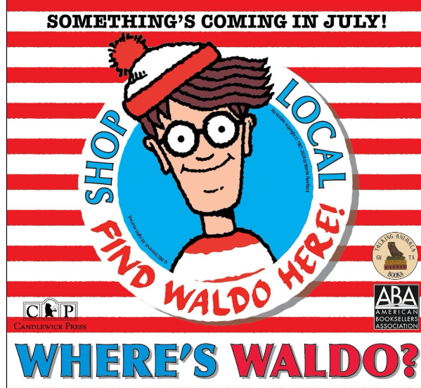

**Talking Animals Books**  
FOR IMMEDIATE RELEASE  
  
FIND WALDO IN GRAPEVINE!  
Grapevine Businesses Join Forces for Beloved National Event Celebrating “Shop Local”   
  
Grapevine, Texas — July 2025 — Where’s Waldo? In Grapevine, of course! This summer marks the 13th anniversary of Find Waldo Local, a beloved national event that turns communities into interactive hide-and-seek adventures. Once again, **Candlewick Press and the American Booksellers Association** are teaming up with more than 325 independent bookstores nationwide, including Grapevine’s own **Talking Animals Books**, to bring families together for a month-long celebration of reading, community, and shopping locally.  
  
There is no charge to participate, and the hunt lasts for the entire month of July!  
  
Families love joining the scavenger hunt to find the iconic children’s book character—known for his red-and-white-striped shirt and black glasses—hidden in more than 25 local businesses along Grapevine's historic Main Street. Find Waldo Local is more than just a fun activity—it's a fantastic way to support the “Shop Local” movement by increasing foot traffic to unique, independent businesses that help make Grapevine special.  
  
“Waldo is such a fun way to shake up summer activities and encourage families to explore the amazing shops we have right here on Main Street,” said Talking Animals Books co-owner Katy Lemieux. “We love being part of Grapevine’s incredible community of creative, small businesses. It’s a joy to see families out exploring together.”  
  
To join in the fun, participants can pick up a “Find Waldo Local in Grapevine!” stamp card at any participating store. Each time they spot a miniature Waldo figure, they get their card stamped or signed by the business. This year, eagle-eyed hunters can also search for Waldo’s special 2025 red-and-white-striped magnifying glass hidden inside Talking Animals Books!  
  
Participants who collect stamps or signatures at 20 or more locations will be entered into a grand-prize drawing for Waldo books and other exciting prizes generously donated by local businesses. Everyone is also invited to the Waldo Wrap-Up Party and prize drawing at Talking Animals Books on August 3, 2025.

Katy Lemieux

Co-owner, Talking Animals Books

[www.talkinganimalsbooks.com](http://www.talkinganimalsbooks.com)