Freedom from Hunger 2026 Promotional Toolkit
Thank you for joining the 12th Annual Freedom from Hunger campaign!
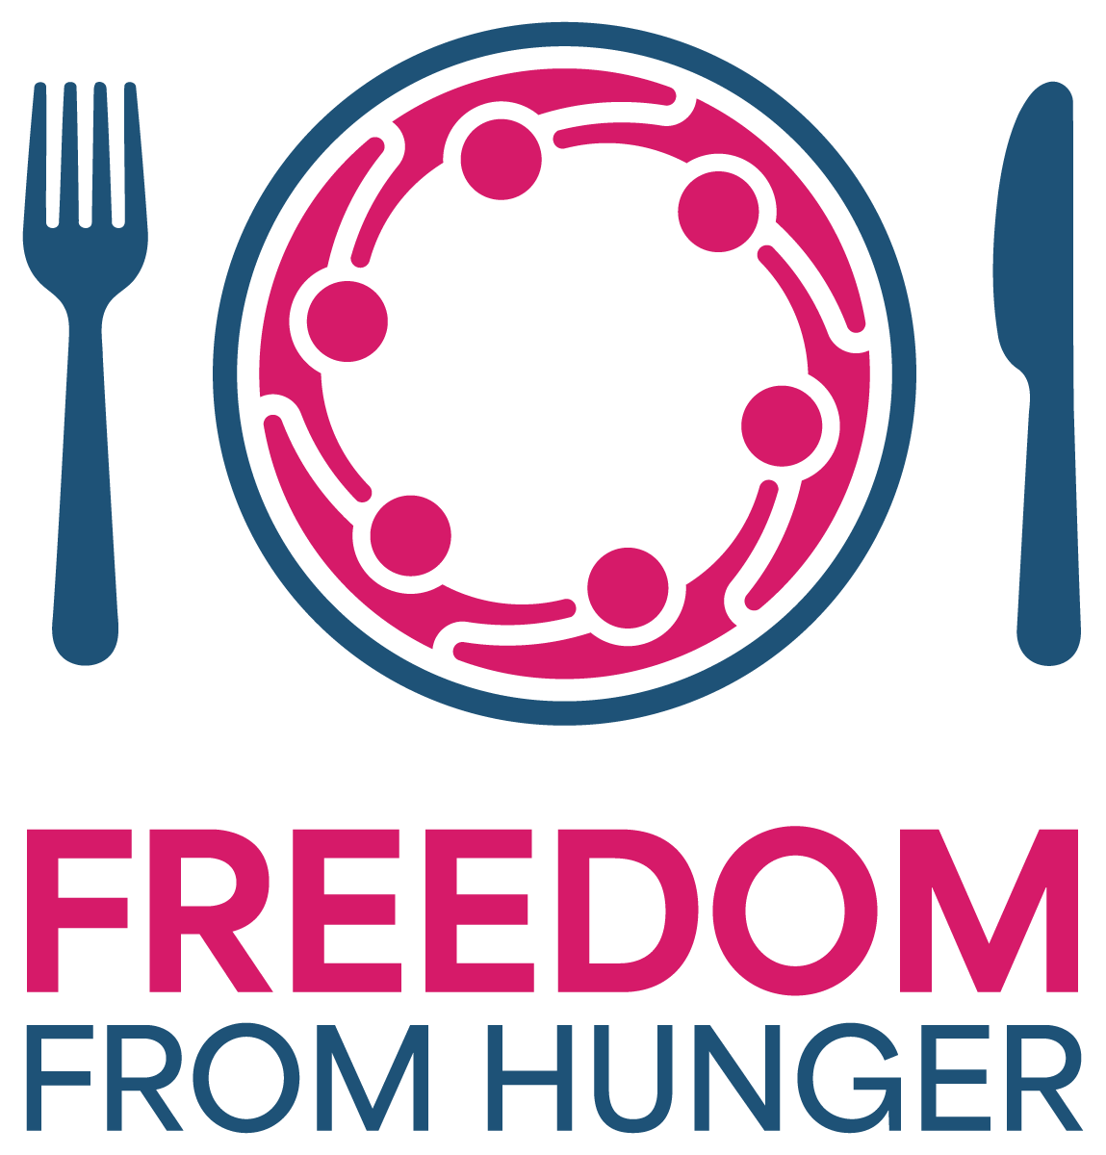

Campaign Overview
Freedom from Hunger is an annual community fundraising campaign led by the Valley Forge Tourism & Convention Board in partnership with the MontCo Anti-Hunger Network (MAHN). Funds raised help MAHN support more than 70 food pantries and soup kitchens throughout Montgomery County.

How you can help:
Help us raise awareness by sharing Freedom from Hunger with your customers and followers. Post about the campaign on social media, use the graphics provided, and encourage your community to get involved.

Graphic & Logos:
https://www.dropbox.com/scl/fo/jhqnwbmt9nvikkrha6gzf/AP6byma8ZkvXLNpjI_KKgqM?rlkey=u5kt76vumetxs1zeit7guj7ar&st=r0jep1g1&dl=0

Donation Link:
https://www.valleyforge.org/hunger/

Suggested Social Media Caption:
We’re proud to support Freedom from Hunger – an annual campaign benefiting the MontCo Anti-Hunger Network and the more than 70 food pantries and soup kitchens it supports throughout Montgomery County. Join us in helping fight food insecurity in our community! Donate today at valleyforge.org/hunger.

Helpful Facts
• MAHN supports 70+ food pantries and meal providers.
• Monetary donations stretch further through bulk purchasing.
• $1 can provide approximately 7 pounds of food (about 5.8 meals).

Tag Us
Instagram: @VisitValleyForge
Facebook: Visit Valley Forge
LinkedIn: Valley Forge Tourism & Convention Board
#MakeItMontco #FreedomFromHunger

Need Help?
Freedom from Hunger Help:
Name: Aja Cramer
Email: cramer@valleyforge.org
Phone: 610-834-7975
Social Media Help:
Name: Tessa Robinson
Email: robinson@valleyforge.org
Phone: 610-716-2299

